Latihan Soal Pertemuan 7
Muhammad Andhany Bahar / 20
TI 1C

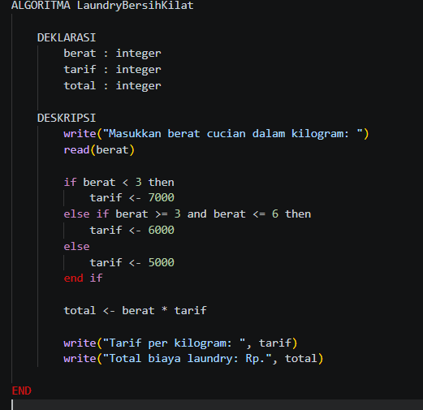
SOAL 1: Laundry Kiloan Dekat Kampus

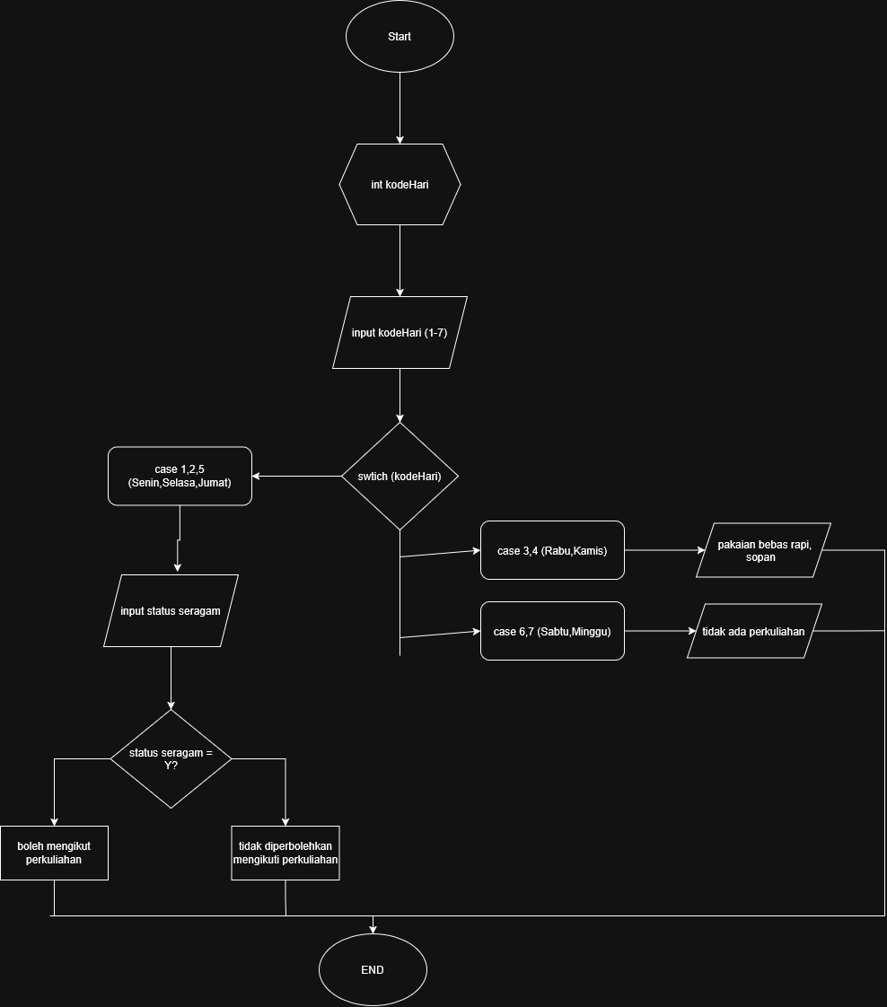
SOAL 2: Aturan Seragam Perkuliahan

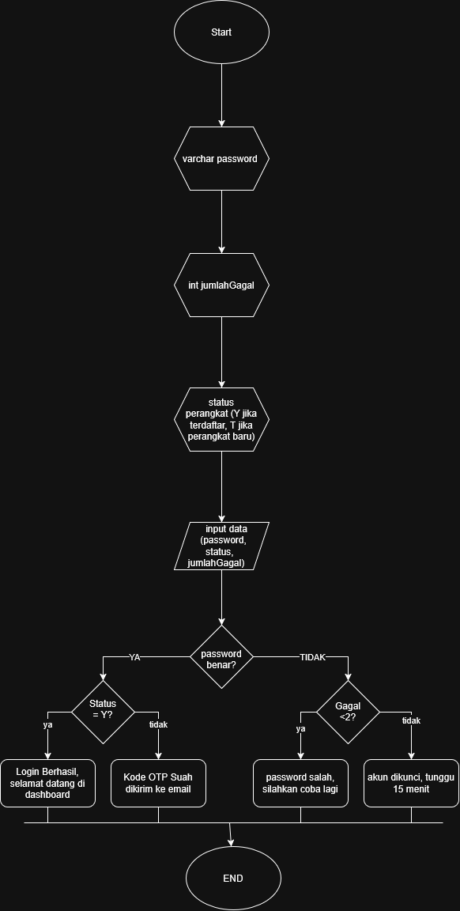
SOAL 3: Sistem Login Learning Management System (LMS) Kampus

